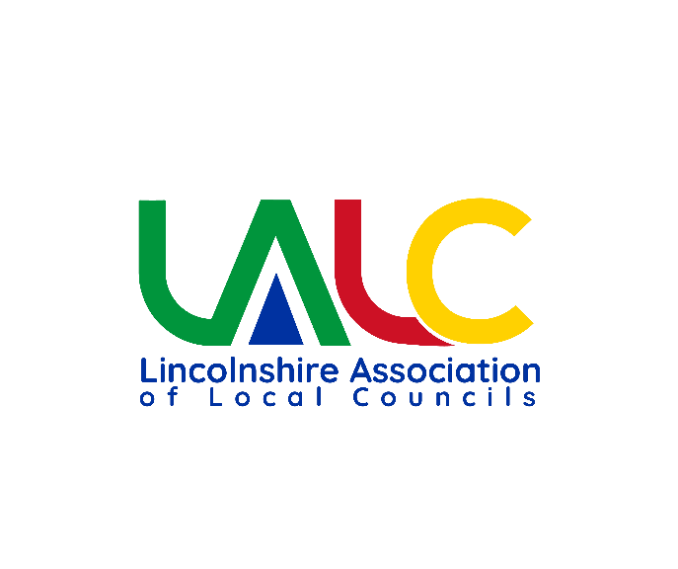

Internal Audit Report.
Council: | Wrangle
Internal Auditor: | Ann Fletcher
Year Ending: | 31st March 2025
Date of Report | 30/05/2025

This internal audit has been conducted in accordance with JPAG The Practitioners’ Guide - March 2024 - Section 4 ‘Internal Audit’. It is recommended that a council completes an intermediate mid-year audit which allows any weaknesses in governance and internal controls to be corrected during the financial year and an end-of-financial-year audit.
Internal audit is the periodic independent review of a council’s internal controls resulting in an assurance report designed to improve the effectiveness and efficiency of the activities and operating procedures under the council’s control. Managing the council’s internal controls should be a day-today function of the council through its staff and management and not left for internal audit. It would be incorrect to view internal audit as the detailed inspection of all records and transactions of a council to detect error or fraud. This report is based on the evidence made available to me and sampling tests undertaken by me and consequently the report is limited to those matters set out below.
The council is required to take appropriate action on all matters raised in reports from internal and external audit and to respond to matters brought to its attention by internal and external audit. Failure to take appropriate action may lead to further audit enquiries being raised and the external auditor issuing a qualified opinion.

Lincolnshire Association of Local Councils
Internal Audit Report.

To the Chairman of Wrangle Parish Council
I have examined council business documents including policies, agendas & minutes, accounting and financial statements and other documents relevant to this internal audit.
I confirm that I am independent of the council, its officers and councillors and its activities and I identified no conflicts of interest to my work with this council to the best of my knowledge.
The results of this internal audit are recorded on the next page. If any part of the audit was found to ‘unsatisfactory’ I have provided recommendations to improve the weakness identified.

Yours sincerely

Ann Fletcher
Internal Auditor

Lincolnshire Association Local Councils

Date: 30.5.25

Area of work checked | Outcome
Implementation of previous auditor recommendations | Unsatisfactory
Implementation of previous AGAR weaknesses/ recommendations | Unsatisfactory
Key Governance Review | Unsatisfactory
Transparency | Unsatisfactory
Accounting | Unsatisfactory
Budget | Unsatisfactory
Income Control | Unsatisfactory
Bank Reconciliation | Unsatisfactory
Petty Cash | Not applicable
Asset Control | Unsatisfactory
Risk Management | Unsatisfactory
General Administration | Satisfactory
Proper Process/Practice | Satisfactory
Payroll/HR | Unsatisfactory
Transaction spot checks | Satisfactory
Year-end process | Unsatisfactory
Allotments | Satisfactory
Cemetery/burials | Not applicable
Charities | Not applicable
Community Buildings | Not audited
Markets | Not applicable
Other: | Choose an item.
Other: | Choose an item.

Recommendations
- Recommend clerk uses Financial Regulations, Standing Orders, Practitioners Guide and Information sent out by external auditor in respect of annual audit as working documents to refer to on a day to day basis which will help to “get it right” first time and improve clerk’s knowledge and effectiveness.
- Clerk to review Cash Account spreadsheet as a matter of urgency to use to record income, expenditure and show current financial position of Council. Review budget lines and incorporate into Cash Account spreadsheet which will aid producing a budget report and bank reconciliation monthly.
- Clerk and Council to use Internal Audit checklist to raise their awareness of the Statutory requirements. Items marked* are statutory requirements.
- Council could consider setting up an HR committee to support the clerk with a structured training plan with progress reviews, payroll, pension and employment policies and procedures. Also to administer a proper documented recruitment process that adhere to the statutory requirements.
- Council could consider temporarily reviewing and perhaps increasing clerk’s working hours to enable her to work on the items raised in this report, if she is able to do that.

Recommendations regarding the Annual Governance Statement 2024-25
Annual Governance Statement Assertion | Internal Auditor comments
1. We have put in place arrangements for effective financial management during the year, and for the preparation of the accounting statements. | Cash account spreadsheet does not provide a running balance of the cash account and income is not recorded on that spreadsheet. Budget approved but not monitored throughout the year. Bank reconciliations not reviewed by members of the authority and not minuted.
2. We maintained an adequate system of internal control including measures designed to prevent and detect fraud and corruption and reviewed its effectiveness | Financial Regulations and Standing Orders are an out of date version. Standing Orders are not visible on website and part of the Financial regulations are missing also on the website. No risk assessment or risk review in place. Council did not adhere to Employment and pension legislation.
3. We took all reasonable steps to assure ourselves that there are no matters of actual or potential non-compliance with laws, regulations and Proper Practices that could have a significant financial effect on the ability of this authority to conduct its business or manage its finances | Council owned email account in place. No evidence that the Council has considered if it is acting within its powers. Not all Statutory requirements have been set up and adhered to.
4. We provided proper opportunity during the year for the exercise of electors’ rights in accordance with the requirements of the Accounts and Audit Regulations. | Correct procedure followed regarding exercise of public rights. Final report from external auditor not published.
5. We carried out an assessment of the risks facing this authority and took appropriate steps to manage those risks, including the introduction of internal controls and/or  external insurance cover where required. | No Risk register or risk management in place. Fixed Asset register not reviewed at year end and does not contain sufficient information.
6. We maintained throughout the year an adequate and effective system of internal audit of the accounting records and control systems. | Internal Auditor appointed through the County Association and is independent of the Council and it’s members. All documents requested were provide in a timely manner.
7. We took appropriate action on all matters raised in reports from internal and external audit. | 23/24 external audit, action taken on matters raised. No report received from Internal Auditor who only completed the AGAR Internal Audit report. 24/25, Authority has had an extensive Internal Audit completed at the end of May 2025 and is starting to work on the recommendations raised already. I would recommend having an interim audit in future.
8. We considered whether any litigation, liabilities or commitments, events or transactions, occurring either during or after the year-end, have a financial impact on  this authority and, where appropriate, have included them in the accounting statements | Nothing noted.
9. Trust Funds | N/A

-End of Internal Auditor’s Report-

